TESTING THE GFCI
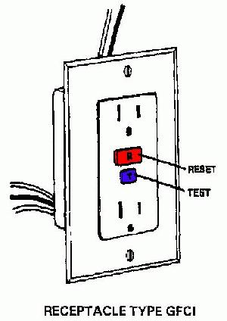
All GFCI outlets should be tested once a month to make sure they are working properly and are protecting you from fatal shock. GFCI outlets should be tested after installation to make sure they are working properly and protecting the circuit.
To test the GFCI outlet receptacle, first plug a nightlight or lamp into the outlet. The light should be on then press the "TEST" button on the GFCI. The GFCI "RESET" button
Should pop out, and the light should go out.
If the "RESET" button pops out but the light does not go out, the GFCI has been improperly wired. Contact an electrician to correct the wiring errors.
If the "RESET" button does not pop out, the GFC1 is defective and should be replaced.
If the GFCI is functioning properly, and the lamp goes out, press the "RESET" button to restore power to the outlet.
All electrical repairs and updates should be performed by a Licensed Electrician.

Wilhelm Home Inspection (603) 580-2023

